MATLAB Project 2

Robert Skelton

Plot of x[n] = n

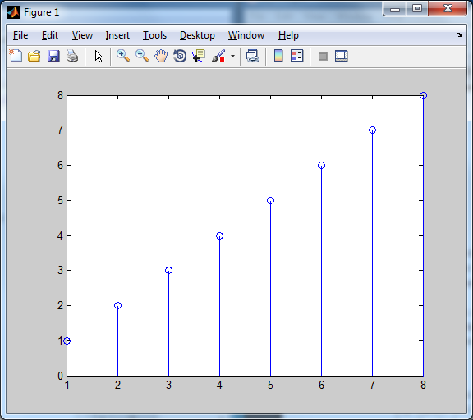

Plot of y[n] = 2

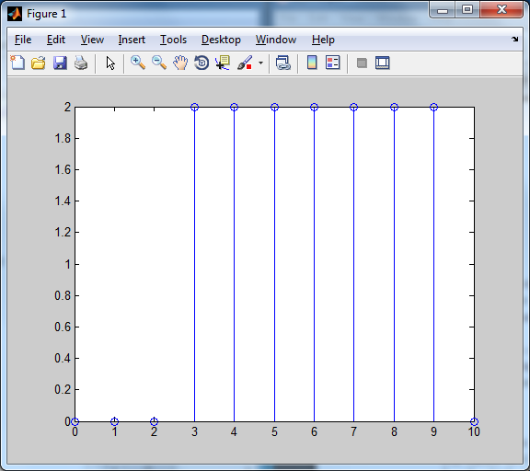

Z = conv(x,y)

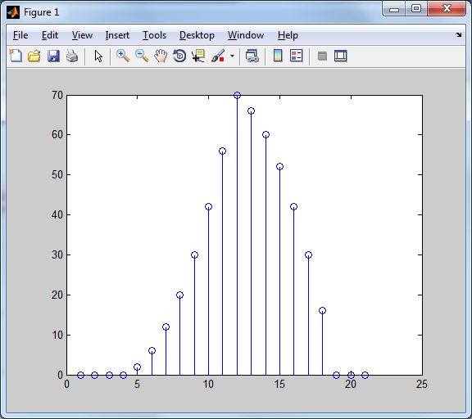

Commands Used:

dtx = 0:10;

x = dtx;

x(9) = 0

x(10) = 0

x(11) = 0

y = 2;

dty = 0:10;

y = [0 0 0 2 2 2 2 2 2 2 0 ];

stem (dty,y)

stem(dtx,x)

z = conv(x,y)

dtz = 0:10;

stem(z)